LAB ASSIGNMENT -2.2
2303a51684
BATCH:29

TASK-1
Prompt : Generate a python code for function that filters out all negative numbers from a list

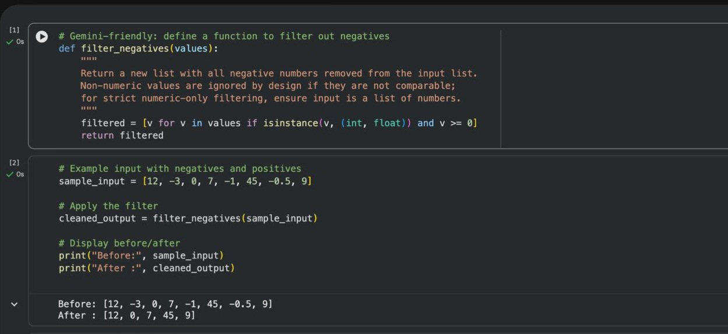

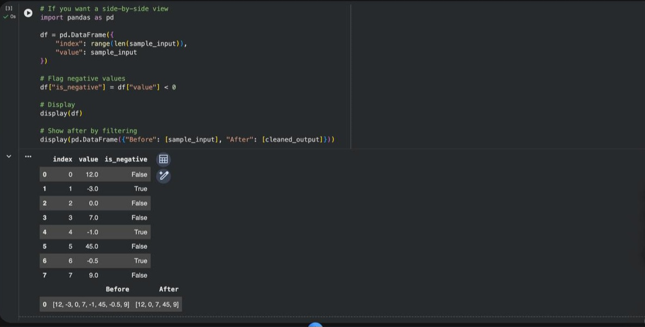
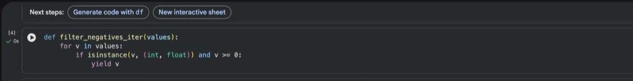
TASK-2:
Prompt : generate a Python function that counts vowels, consonants, and digits in a string.

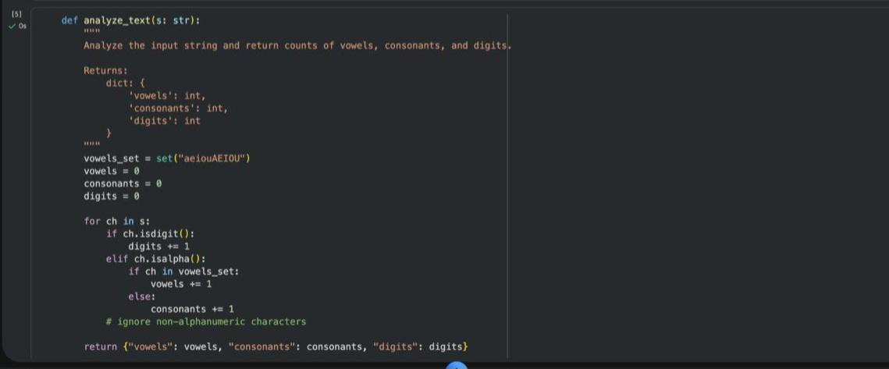
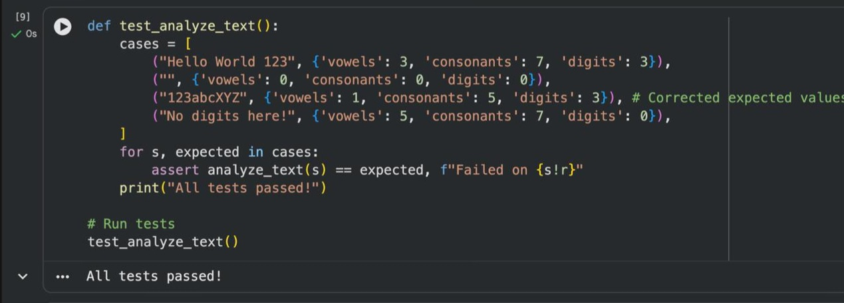

TASK-3:
Prompt : Generate a palindrome-checking function using Gemini and Copilot, then compare the
Results.
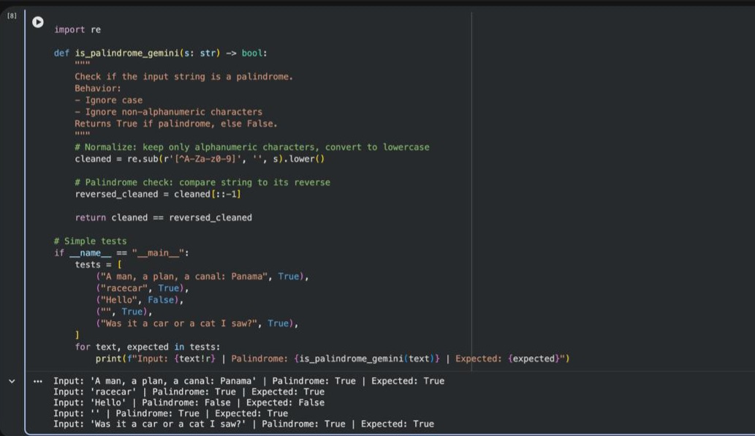

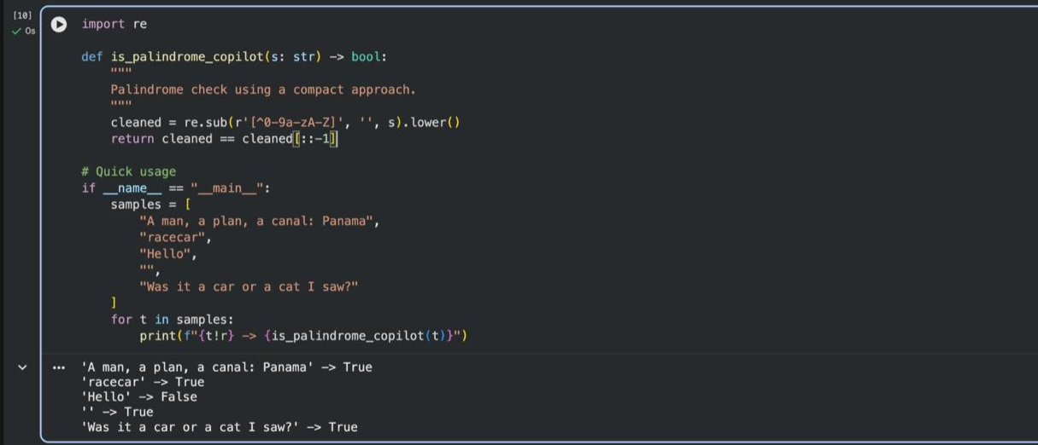

TASK-4:
Prompt: explain a Python function (prime check OR palindrome check) line by line.

